

PIPELINE ROW PATROL INSPECTION REPORT

# AIR PRODUCTS PIPELINE

(1133 - 8” CO2 || Port Arthur Area)

June 2, 2025

# CONFIDENTIAL DOCUMENTS

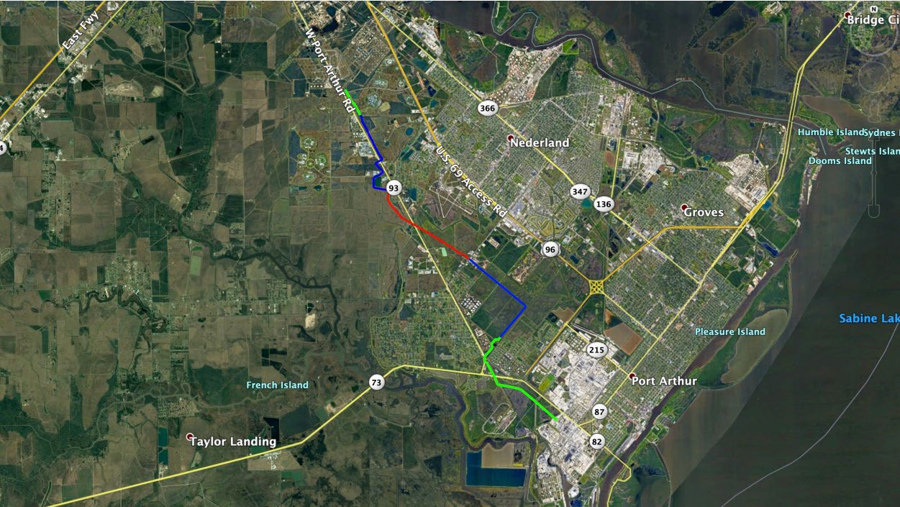

Arch Aerial, LLC 3701 Yale Street

Houston, TX 77018

281.974.5752